Capacity Building Support to the Sierra Leone Correctional Services on
Correctional Institution Management:
Provided by the International Corrections Management Training Centre (ICMTC)
With Support from INL
Canon City, Colorado, USA
7-21 October, 2016

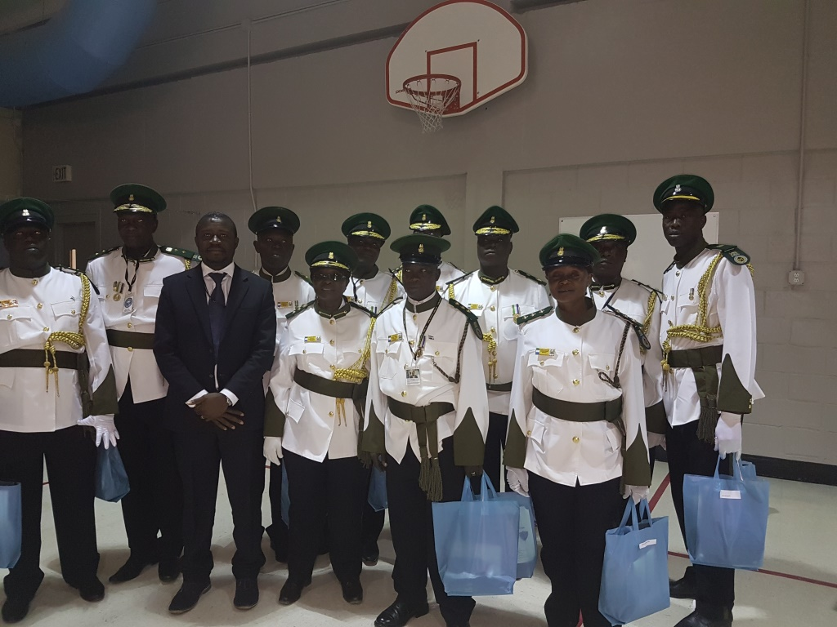
SLCS Senior Management, staff participants and UNDP Rule of Law Programme Specialist at the graduation ceremony of the CIM training course in Canon City, Colorado, USA

Brief Overview & Objective of the Training Program
The Sierra Leone Prison Department has been transformed by an Act of Parliament in 2014 that revolutionized the approach to detention with the corresponding anticipation of gradually shifting from a punitive to a reformative institution. That goes in line with ensuring greater protection of the rights of people in detention and the need to ensure offenders who enter detention centers come out to be productive for their families and society at large. The overall objective of this support was to improve on the capacity of senior management and backroom staff of the Sierra Leone Correctional Services (SLCS) to drive change within the institution. That, it is hoped would in turn strengthen the institutional capacity of the SLCS as well as improve on other staff’s capacity with the overall goal of upholding human rights of inmates and improve on the safety and security of staff, inmates and society. At the end of the Correctional Institutional Management (CIM), the enthusiasm displayed by participants from Sierra Leone showed a keen interest from the SLCS management to ensure that the human rights situation of inmates, standards and their productivity are improved with specific emphasis on transforming the SLCS institutional systems and practices.

Synopsis of the Two (2) Week CIM Training Course
The training was introduced by an overview of the program focusing on the fact that different jurisdictions are called to apply different methods of ensuring proper administration of correctional facilities. For example, policies, the laws, command structures and many other internal dispositions might vary depending on the context. However, the overarching goal to ensure the respect of human rights of inmates and the security and safety of staff and society must be pursued. Colorado has got over 20 prisons with more than 21,000 offenders served by about 6,300 staff (very limited staff as compare to the inmate population). Correctional facilities are classified as follows:
- Minimum,
- Minimum restricted
- Medium
- Closed
- Restrictive housing

One common denominator between correctional facilities in Sierra Leone and Colorado: Offenders and Staffing. Because offenders have already been punished by the justice system, the role of a correctional facility is to manage the offender and ensure his reintegration into society. The importance of reintegrating an offender is driven by the fact that the society does not want to see more victims. Overall, the recidivism rate in Colorado is pecked around 45-55%, which means that about 45-55% of offenders are also successfully reintegrated into the society.

Highlight was placed on the need to ensure a proper classification of offenders, which is the central component, the success of which is responsible for the success of any initiative relating to the offender.

Visit to the Fremont County Jail and Court House
The Fremont County Jail is a detention facility for offenders making their entry into the criminal system. As such it has a very strong data system which captures specific information on inmates. Services provided to offenders include medical assistance, communication with family members, and interaction with detention personnel…etc. Treatments for drug and alcohol abuse and mental attention are proposed as alternatives to detention of offenders and must receive the full cooperation of the offender.

The District Court and other inferior courts are situated within the same confines of the County Jail. This enables a flow of movements from the Court to the Jail as well as ensures the security and safety of staff and the community in the movement of offenders.

Presentation on the Sierra Leone Correctional Services (SLCS)- Director General, SLCS
Pointers:
- The SLCS formerly known as the Prison Department is a heritage of the British colonial era with more than 100 years of existence.
- It has moved from a punitive to a correctional aspect in 2014 with the enactment of the Sierra Leone Correctional Services Act.
- The prison system works on a remission basis with 1/3 of sentence remitted and 2/3 served by a convict across 19 prisons/correctional facilities nationwide (17 male and 2 female facilities)
- Inmate population of about 3,150 (including 110 female inmates), with about 60% of the inmate population being pre-trial detainees.
- Inmates are sent to the correctional facilities through court decisions after charges are proffered by the police or the Law Officers’ Department. Pre-trial detainees who are convicted continue to be remanded.
- There is limited electricity supply, many things are done manually: records keeping, doors…etc.
- Industries existing include: plumbing, carpentry, tailoring, welding…etc. Skills acquired by inmates are however not competitive because of the lack of a proper certification mechanism.
- Correctional facilities are host to both pre-trial detainees and convicted offenders making it extremely difficult to classify facilities, plan and execute specific programs e.g. industries.
- There is an increase in crime rate and the extension of magistrates and high court across the country contributes to increase the prison population. But this has not corresponded to an increase in the capacity of the SLCS to deal with the new challenges (limited number of vehicles to convey prisoners…etc.).
- Lack of classification of inmates as well as inability to categorize correctional facilities continues to hinder efforts toward developing skills programs that can benefit inmates or prepare them to reintegrate their community.
- There is very limited cooperation with the Judiciary and the Police as intelligence is limitedly shared.

Standards Minimum Rule for Treatment of Prisoners: The Mandela Rules
As a general principle, rules of general application within a correctional facility should be rules applicable to any institution in which a person may be held, detained, restrained, removed from society or incarcerated for any period of time. The Mandela Rules set out generally acceptable principles as good practice for the minimum treatment for prisoners. These standards become defensible in court once breached. They include the following:
- Prohibition of discrimination based on age, race, ethnicity, sex, criminal records,
- Decent accommodation, access to basic human rights (health, water, sanitation…etc.)
- Impartial application of standards in custody,
- Respect for the human dignity…etc.

To ensure that the above mentioned rights are upheld, there is need for a proper classification to be carried out in order for offenders to be housed in relation to the risk they pose to staff and society. It was also acknowledged that it could be difficult for the rules to be respected especially when there is poor infrastructure and limited political committed, like in the case of SL.

The session was very interactive with participants keen to know how much can be done within the Mandela Rules to address the perennial issue of overcrowding across Sierra Leone correctional facilities. It was revealed that the construction of additional facilities might not necessarily lead to decongestion, but there was need to ensure that the discussion is started across the justice chain for remedial steps to be reached.

Classification: Initial and Internal-Advantages/Disadvantages of an Objective Classification System/Pre-Assessment, Mandela Rules
Simply put, classification refers to the process of answering the question as to ‘why’ people are in prison. This process entails collecting as much information as possible from various sources on the offender. Classification is ultimately aimed at ensuring the safety and security of an offender, staff and that of the community. This process can take into account ethnicity, belonging to a gang, drug abuse, violent conduct, age, race, level of vulnerability. This enables the offender to be properly placed for behavioral change programs. Classification is a method used to manage an offender.

Classification needs to be objective in order to provide the administration with a decision making mechanism. It is a set of well-defined legal factors taking into account the personal characteristics fitting within a policy defined factors or mechanisms. The benefits of classification include technical clarification, resources management and policy development. A proper classification unavoidably leads to the development of a classification philosophy to aid the administration of offenders. For example, discussions revealed that the Colorado system of classification is based on the philosophy of incentive which enables offenders to be paid for work done and with positive behaviour leading to lower custody.

Visit to the Denver Reception and Diagnostic Centre (DRDC)/Intake, Case Management Overview and the Denver Women’s Correctional Facility Programs
The DRDC is the sole facility within the state of Colorado responsible for the intake, classification, case management and placement of offenders (both males and females) in suitable correctional facilities within the state. The Intake Unit plays the central role of filtering through convicted offenders arriving from all jurisdictions within the state. The Unit gathers information on offenders prior to their arrival: name, date of birth, family situation. The classification unit of the DRDC ensures information gathering and research on offenders, data base info, info on security threats, assessment of programs suitable for offenders, level of custody classification, determination of custody level suitable for offender; conversion of info from paper file to electronic system. At the conclusion of the classification process, offenders are processed and channeled through a suitable level based on findings and existing criteria.

Discussions revealed that only an objective and principles driven classification process would drive the amount of success registered within the state of Colorado. In addition, it was revealed that many of the programs generate significant amount of money with many inmates absorbed in mainstream society or self-employed. On the issue of recidivism, it was stated that the rate of recidivism within offenders successfully going through a program before release was as low as 19% as compared to 45-55% for offenders released without completing any industrial program.

Special Teams/Searches and Shakedowns
The presentation delved into the formation of teams to handle specific issues arising within the Correctional facilities in the USA as well as searches procedures. Some of these teams include the Rapid Response Team (RRT), the Emergency Response Team (ERT), which is facility-based established as per the category of the facility. The Special Operations Response Team (SORT) can provide a response to a situation state wide. The type of equipment used varies as per the type of response and the level of the facility. The Critical Incident Response Team (CIRT); the Search Team (ST), the Crisis Negotiation Team (CNT) is employed for attempted suicide, hostage taking and special needs. The CNT requires adequate communication and negotiation skills.

The presentation revived discussions from participants on existing structures back home and how they could be reshaped and roles redefined to ensure the handling of incidents is done in a professional and rights-based manner.

Key and Tools Control Procedures
Importance of key control; safety, security, prison protocol, minimizes escapes. Staff should know how many keys are in a key ring. Key control is essential to protect the public, other offenders and staff. In any event of a missing key, facility must be lock down for shake down (search). Missing keys are a huge and costly exercise because it might affect the whole chain of locks.

It was evident from the discussion during the presentation that there was no policy or arrangement in place for the handling of keys within the SLCS and the successful handling so far depended on the good will of staff. In was also made known that tools control was as essential as the key control. The loss of a tool exposes other inmates, staff and the community. Tools are classified in 3 categories: class A, B and Controlled Items. Class A tools are shadowed Red and are classified as per the level of the facility. Class B tools are shadowed yellow while Controlled Items are shadowed black.

A conclusion was reached that a tool and key policy would be adequate to address shortfalls discussed on the SLCS system to ensure the safety and security of staff, offenders and society. Searches and shakedowns it was also revealed were administrative processes aimed at minimizing the inflow of contraband in detention facilities. Contraband it was revealed could be introduce with assistance of staff. It was thus important to develop a culture of professionalism and team work.

Leadership, Ethics and Professionalism
Leadership is critical in the running of correctional facilities and the need for clearer roles and responsibilities cannot be over-emphasized.
Due to the numerous constraints faced by the SLCS including overcrowding in detention centres, participants were keen to receive ample details as to how they could help mitigate challenges. The Colorado Department of Corrections it was explained are using a probation method, Sentencing options, community-based corrections and Parole as strategies to minimise over-crowding. Nevertheless, it is clear that the separation of pre-trial detainees and convicted offenders has contributed to the limited overcrowding within state correctional facilities.
The Code Of Penal Discipline (COPD)
Discipline in facilities is of paramount importance and the Code as implemented within the state of Colorado has helped to ensure that offenders were aware of disciplinary measures set to regulate their behaviour within the facilities. Worth noting was the fact that the Code is made available for all inmates contrary to what obtained in SL. In Sierra Leone, the Prison Rules of 1961 (which would be revised and redrafted with support from INL funds under the new 27 months SLCS project).
Ensuring enforceability, fairness and security focused should be the guiding principles in the process of establishing disciplinary rules.
Correctional Industries
Correctional industries in the state are regulated by legislative powers empowering correctional facilities to operate as business. This sector within the state generates revenues as well as provides a significant amount of service to state agencies. The overall objective is to ensure offenders are kept busy while serving their term of imprisonment and have an opportunity to gain some skills while in detention. This department plays a vital role in the rehabilitation and reintegration of offenders upon release.
With over 70 different agricultural, manufacturing and service programs, the wide range of skills available has been a key factor in keeping the recidivism rate lower as offenders not part of any skills enhancement program.
Action Plan Developed by SLCS for Implementation upon Return from Training
The training concluded with participants developing an Action Plan highlighting critical areas for intervention in the short, medium and long term. As reiterated during presentations, it was agreed that activities should be implementable with limited or no costs that might impair ability of the SLCS to carry out.

Action Plan-SLCS
Short Term | Medium Term | Long Term
Develop a Policy on keys and tools control | Purchase of locks and tools for identified facilities
Train staff on the implementation of key and tool policy | Establish shadow boards in facilities host to correctional industries
Develop a policy for coordination between SLCS and other criminal justice partners | Create synergies with other justice stakeholders | Establish a sustained platform for collaboration with other justice sector actors
Develop a policy and procedural guidelines for the transportation/escort of inmates | Procure escort gadgets and vehicles | Conduct regular refresher courses on policy
Establish escort units across all correctional facilities
Develop a communication policy | Conduct regular trainings on communication for officers | Procure sophisticated communication gadgets
Develop a policy on incident management | Establish central communication units | Conduct periodic training sessions (refresher courses)
Classify offenders on a Reward System | Construct workshops for small scale businesses for inmates | Increase production targeting markets
Develop policy and MoU on prison-community relationship | Undertake joint community sensitization | Identify long term viable programs in order to foster good relationship between communities and corrections
Formulate policy and guidelines on Re-entry programs | Train officers on various relevant to offenders re-entry programs | Strengthen partnership with relevant community re-entry service providers
Reorganize the Rapid Response Unit (RRU) and develop Standard Operating Procedures (SOP) to guide their operation | Organize regular physical exercises and periodic training for RRU personnel | Setting up a crisis negotiation team (CNT) and drawing up policy guideline for smooth operation
Setting up search teams in all correctional facilities and develop guiding principles for their operations | Reconstitute the Armed Response Unit and develop regulations for the units | Set up a Critical Incident Response Team (CIRT) and develop policy for effective operation
Develop a policy (SOP) on classification | Classify inmates in various correctional centres | Engage Ministry of Education and CSOs to incorporate offender education programs in the general school curriculum
Classify various correctional facilities into minimum medium and closed facilities | Mobilize trained staff to commence offender management training programs | Introduce earning schemes (incentives) for inmates participating in offender treatment or education/vocational programs
Develop templates for intake and classification of inmates at entry | Move low risk inmates from high/medium risk facilities to minimum facilities | Construct a closed facility
Develop a policy to direct the operation of correctional industries | Procure basic vocational and farming tools | Procure industrial carpentry and garment machines to improve on quality and quantity of products
Finalize work on the SLCS Show room to display manufactured goods | Improve on the existing structure and lands at Mafanta and Gbenduru | Introduce motor and electrical engineering in 3 pilot correctional centres
 | Intensify and increase farming activities (plant and animal) at Gbenduru and Mafanta | Introduce the cultivation of fish in ponds
Drawing up a declaration (policy) on contraband list and display in all centres | Train staff of search techniques, contraband control and evidence handling | Procure BOSS II chair, metal scanners, alarm system and public address system for all correctional centres
Develop a policy on search | Reconstitute the intelligence unit in all correctional centres | Introduce a canteen across centres
Procure shakedown tools e.g. screw drivers, latex gloves, mirror, paper/plastic bags | Identify specific areas for strip search in all correctional centres | Develop an SOP on inmates clothing and introduce of state-clothing for all categories of inmates

Recommendations to the INL as Way Forward after CIM Course
- Further cooperation and collaboration between the ICMTC and the SLCS needed to ensure deepened engagement on CIM and transformative change within the SLCS correctional management systems and to establish a gradual culture of objectivity that is required to strengthen and improve on correctional processes in a holistic manner across Sierra Leone centers;
- Need for INL to bilaterally continue to strengthen the SLCS classification and reintegration systems beyond the UNDP-INL-SLCS project to ensure detention facilities are managed as per their risk level and the current high rate of recidivism in reduced and thus create a well needed transformative correctional system to meet with emerging needs of inmates;
- The CIM course could be extended to other middle age senior correctional officers with clear selection criteria set up from inception and with support from other organizations working closely with the SLCS like the Prison Watch-SL;
- The ICMTC could be of good assistance to help the SLCS to develop several rules and policies to govern the functioning of all correctional centers across Sierra Leone, building on local realities and on the basis of objectivity and forward looking.
- Continuous follow-up with the SLCS to ensure the Action Plan developed during the 2 week training with no or low cost is implemented.

